Ingredients
For the Chicken
- 2 large chicken breasts (or 4 small fillets)
- 2 tablespoons olive oil
- 1 teaspoon paprika
- 1 teaspoon garlic powder
- 1 teaspoon onion powder
- 1/2 teaspoon chili powder
- 1 teaspoon Italian seasoning
- 1 teaspoon salt
- 1/2 teaspoon black pepper
- 1 tablespoon butter
For the Creamy Pasta
- 12 ounces pasta shells
- 2 tablespoons butter
- 3 cloves garlic, minced
- 1 cup heavy cream
- 1/2 cup milk
- 1 cup grated Parmesan cheese
- 1/2 teaspoon salt
- 1/2 teaspoon black pepper
- 1/2 teaspoon dried parsley (plus more for garnish)
- 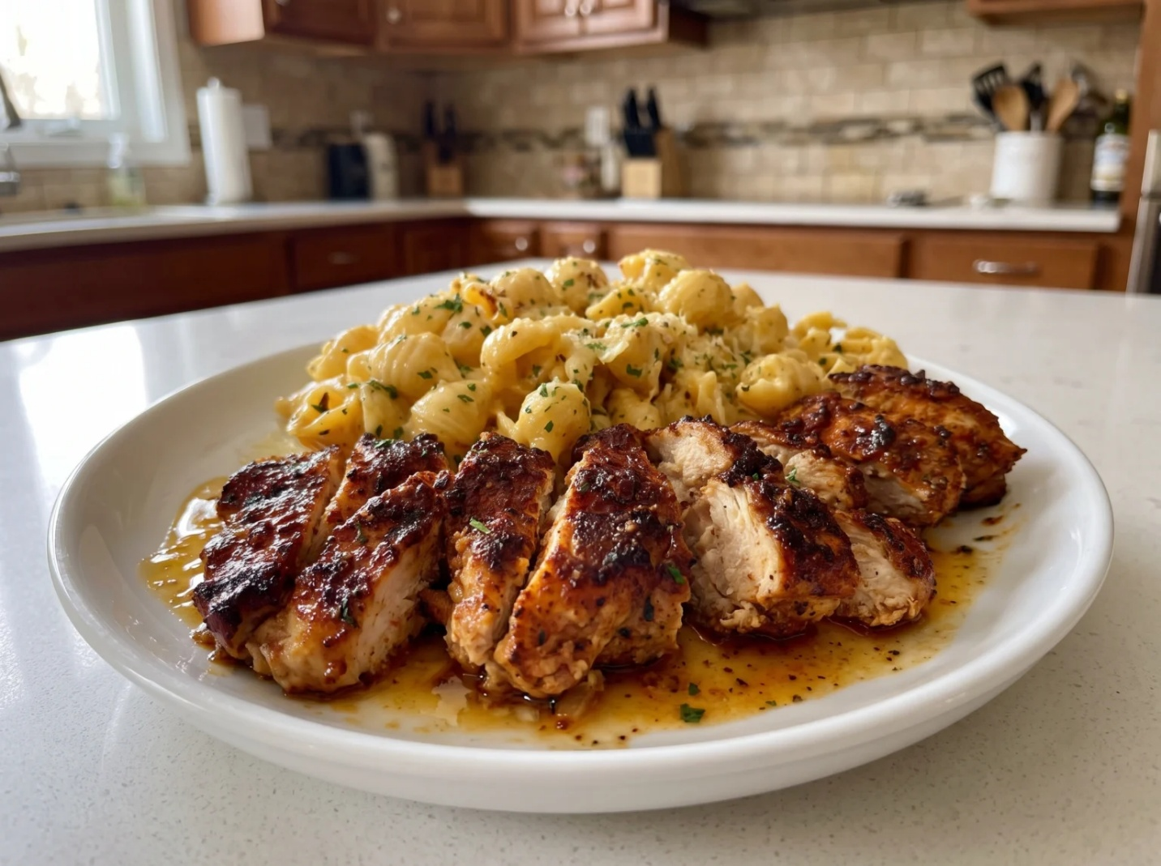
Instructions
Start by cooking the pasta. Bring a large pot of salted water to a boil and cook the pasta shells until al dente according to package instructions. Drain them and set aside, keeping them slightly firm so they hold up in the sauce.
While the pasta cooks, prepare the chicken. In a small bowl, mix paprika, garlic powder, onion powder, chili powder, Italian seasoning, salt, and black pepper. Rub this spice blend generously over both sides of the chicken breasts until fully coated.
Heat olive oil in a large skillet over medium-high heat. Add the chicken and let it sear for about 5 to 7 minutes per side, until it turns golden brown and cooks through completely. In the final minute, add butter to the pan and spoon it over the chicken as it melts — this adds a rich, glossy finish. Remove the chicken and let it rest before slicing.
Slice the chicken into thick strips and set it aside.
In the same skillet, melt butter over medium heat. Add the minced garlic and sauté for 30 to 60 seconds, just until fragrant and slightly golden.
Pour in the heavy cream and milk, stirring gently as the sauce begins to warm and come together. Let it simmer softly — you’ll notice it start to thicken slightly.
Now stir in the Parmesan cheese, salt, black pepper, and dried parsley. Keep stirring until the sauce becomes smooth, creamy, and rich enough to coat the back of a spoon.
Add the cooked pasta shells into the sauce and toss until every piece is fully coated in the creamy Parmesan mixture.

